**Larayo Barracudas**

2021 Swim Team Suits

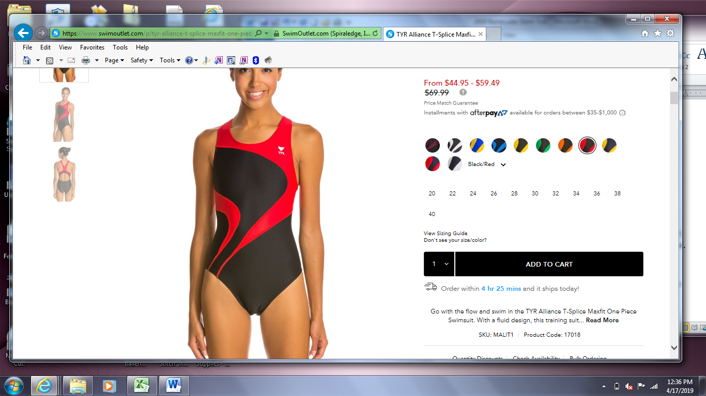 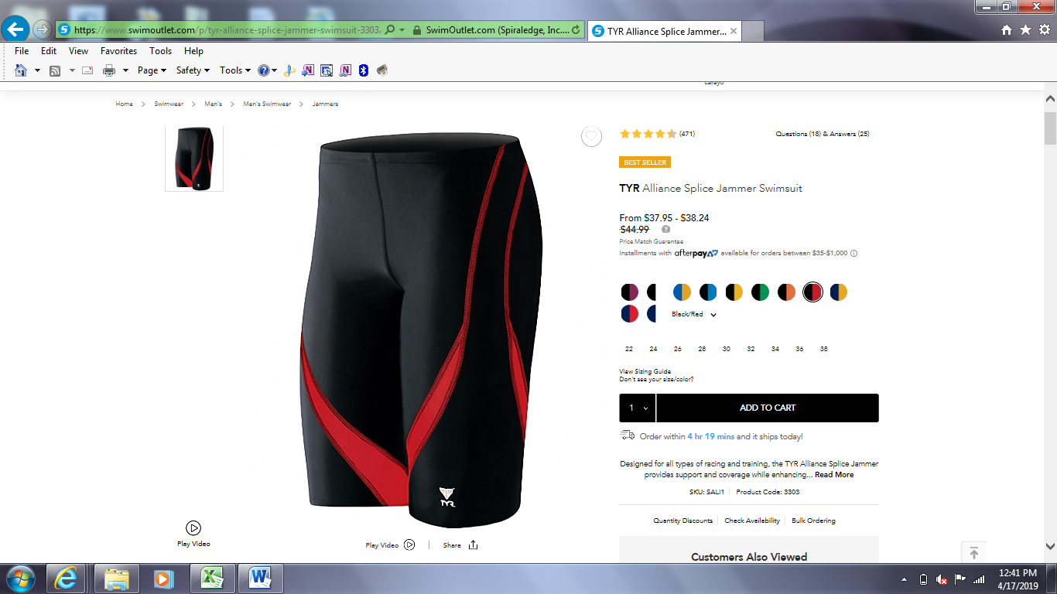 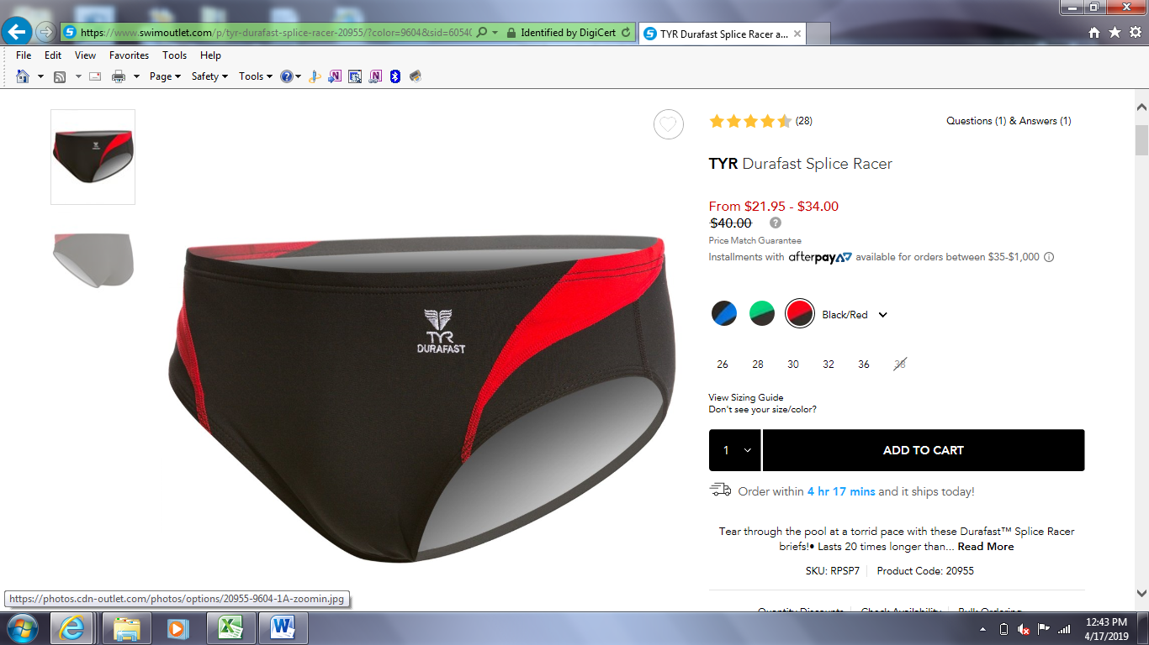

TYR Alliance T-Splice Maxfit

Black/Red

TYR Alliance Splice Jammer

Black/Red

TYR Durafast Splice Racer

Black/Red

Larayo Barracudas now have a swim store on SwimOutlet.com and will get credit for any order placed through the link below!!

**https://www.swimoutlet.com/larayoswim/**

Type the link above to enter the Larayo store, or you may go to [www.swimoutlet.com](http://www.swimoutlet.com), click TEAMS at the top right, then click FIND YOUR STORE, then scroll down to search for “LARAYO”.

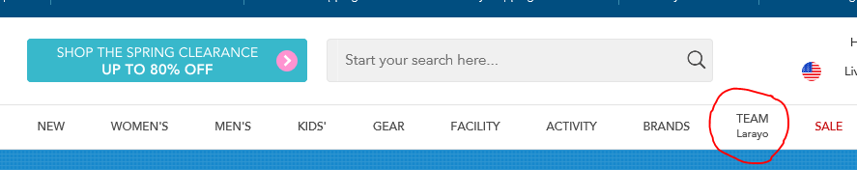

Once you see Larayo as your team, you may shop for products within the team store *or* on the regular swim outlet page. Larayo will receive credit for all items as long as our team is selected!

If you are unable to order through Swim Outlet, you may find your swim suit on other sites.